WEEK 5: Microservices with Spring Boot 3 and Spring Cloud

Creating Microservices for account and loan

**Build the Account Microservice**

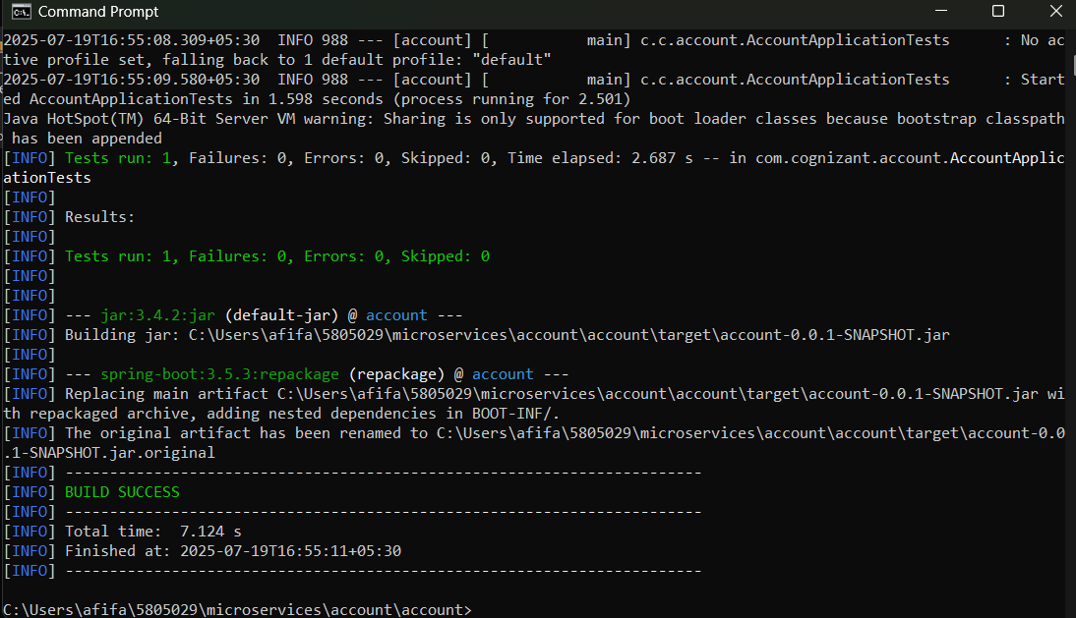

package com.cognizant.account.controller;

import org.springframework.web.bind.annotation.GetMapping;

import org.springframework.web.bind.annotation.PathVariable;

import org.springframework.web.bind.annotation.RestController;

import java.util.Map;

@RestController

public class AccountController {

@GetMapping("/accounts/{number}")

public Map<String, Object> getAccountDetails(@PathVariable String number) {

return Map.of(

"number", number,

"type", "savings",

"balance", 234343

);

}

}

Account: http://localhost:8080/accounts/{number}

Loan microservice:

* **Account service** is running on:

http://localhost:8080/accounts/{number}

* **Loan service** is running on:

http://localhost:8081/loans/{number}

